**Testing**

**1).Test: To test if the login screen worked**

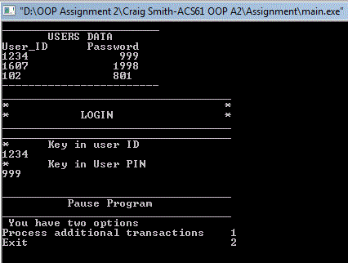

**1).Conclusion:**  The login screen worked

**1).**No changes required

**2).Test: To test if option menu worked correctly**

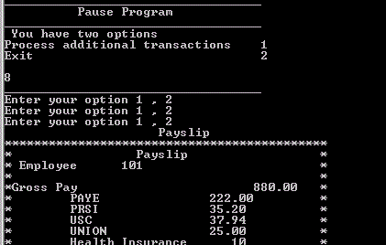

**2).Conclusion:** The option menu didn’t work as it let the user enter any number to go to the next part of the program

**2).Changes made:** I added in the code so that if the user entered a number greater than 2 it wouldn’t access the next part of the program

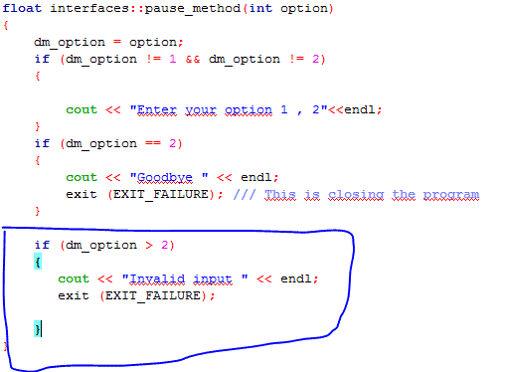

**3).Test: To test if the gross to net report displayed correctly**

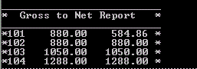

**3).Conclusion:** It displayed fine part of the program

**3).**No changes required

**4).Test: To test if the reporting system worked correctly**

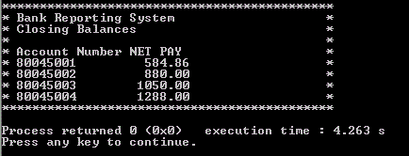

**4).Conclusion:** It worked how it was needed but the spacing and layout was little bit tedious

**4).**Spacing and alignment

**Fully working program**

